

**GOVERNMENT COLLEGE OF ENGINEERING BARGUR**

**( AUTONOMOUS)**

**PROJECT TITLE: TRAFFIC MANAGEMENT**

**TEAM MEMBERS:**

**ANGELINE VEDHA V**

**ARCHANA A**

**GOWRI P**

**DEVADHARSHINI M**

**DIVYADHARSHINI KR**

**NANDHANA SHREE S**

**MANJU P**

**PROBLEM STATEMENT:**

Traffic congestion problems consists of incremental delay, vehicle operating costs such as fuel consumption , pollution emissions and stress that result from interference among vehicles in the traffic stream , particularly as traffic volumes approach a road’s capacity

1. **Assessment and Analysis: a. Identify the area or city where the traffic management system will be implemented. b. Conduct a thorough analysis of traffic patterns, peak hours, congestion points, accident-prone areas, and existing infrastructure.**
2. **Goals and Objectives: a. Define the goals and objectives of the traffic management system, such as reducing congestion, improving safety, and promoting sustainable transportation.**
3. **Technological Infrastructure: a. Determine the hardware and software components needed, such as traffic lights, sensors, cameras, communication devices, and a central control system. b. Ensure that the infrastructure is scalable, adaptable, and capable of handling the expected traffic load.**
4. **Traffic Signal Synchronization: a. Implement a synchronized traffic signal system to optimize traffic flow and reduce congestion. b. Use real-time traffic data and sensors to dynamically adjust signal timings based on traffic conditions.**
5. **Intelligent Transportation Systems (ITS): a. Implement an ITS that uses advanced technologies like machine learning, AI, and data analytics to predict traffic patterns and adjust traffic flow accordingly. b. Integrate real-time data from various sources to make informed decisions and manage traffic effectively.**
6. **Traffic Monitoring and Surveillance: a. Install a network of traffic cameras and sensors to monitor traffic in real-time and detect incidents or congestion. b. Utilize video analytics and image processing to assess traffic conditions and detect violations.**
7. **Traffic Data Analysis: a. Collect and analyze traffic data to identify traffic patterns, peak hours, and congestion points. b. Use data analytics to generate insights for better traffic management strategies and infrastructure improvements.**
8. **Smart Traffic Management Algorithms: a. Develop and implement algorithms that can optimize traffic flow, manage intersections, and reduce wait times. b. Consider adaptive traffic management algorithms that can adjust based on changing traffic conditions.**
9. **Emergency Response Integration: a. Integrate the traffic management system with emergency response services to prioritize emergency vehicles during critical situations.**

**10.Public Information and Communication: a. Implement a public communication system to inform drivers about traffic conditions, alternate routes, and other relevant information through variable message signs, mobile apps, or websites.**

**11.Stakeholder Engagement: a. Involve local authorities, traffic engineers, transportation agencies, and the public in the design and implementation process to ensure a comprehensive and inclusive traffic management system.**

**12.Testing and Optimization: a. Conduct extensive testing to validate the effectiveness and efficiency of the traffic management system. b. Continuously optimize the system based on feedback, performance data, and evolving traffic patterns.**

**13.Education and Outreach: a. Launch educational campaigns to inform the public about the benefits of the new traffic management system and encourage responsible driving habits.**

**14.Regulatory Compliance: a. Ensure compliance with local traffic laws, regulations, and safety standards throughout the design and implementation process.**

**15.Maintenance and Upgrades: a. Establish a maintenance plan to regularly inspect and update the system to keep iteefficient, secure, and up to date with technological advancements.**

**MODEL OF THE PROJECT**

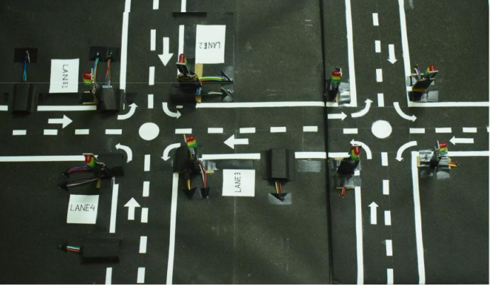**Top of Form**

**USE CASE DIAGRAM**